**Customer churn Analysis for a Telecom Company:**

**Project Overview:**

This data analysis project using Power BI is aims to provide insights into customer churn rate for a telecom company. My aim is to identify trends by examining different aspects of customer data and gain a deeper understanding of the factors those contributing to customer churn.

**Why we need to do Customer Churn analysis:**

In the telecom industry, customers can choose from various companies for their communication and internet need. These communication services have become inseparable from the daily routine now. Coupled with high customer acquisition costs, churn analysis becomes very pivotal.

Churn rate is a metric that describes the number of customers that cancelled or did not renew their subscription with the company. Thus, higher the churn rate, more customers stop buying from your business, and so decreasing the revenue. Based on the insights gained from the churn analysis, companies can build strategies, target segments, improve the quality of the services being provided to improve the customer experience. That is why creating reports of churn analysis becomes key for the growth of company.

**Project Goal:**

Using Power BI, develop a complete ETL process and a Power BI dashboard to leverage customer data to classify the potential churn customers based on numerical and categorical features.

1. Analyze customer data at the below levels- Gender, age group, contract type, Tenure, multiple services and so on.
2. Metrics required - Total Customers, Total churn count, Churn rate in percentage

**Data Source:**

Customer Data: " WA_Fn-UseC_-Telco-Customer-Churn.csv"

The dataset file has 7,043 rows as Customers and 32 columns of customers details as Features.

**Tools:**

Power BI – For Data Cleaning, analysis and Creating reports

**Dataset Attributes:**

* customerID: Customer ID
* gender: Whether the customer is a male or a female
* SeniorCitizen: Whether the customer is a senior citizen or not (yes-1, No-0)
* Partner: Whether the customer has a partner or not (Yes, No)
* Dependents: Whether the customer has dependents or not (Yes, No)
* Tenure: Number of months the customer has stayed with the company
* PhoneService: Whether the customer has a phone service or not (Yes, No)
* MultipleLines: Whether the customer has multiple lines or not (Yes, No, No phone service)
* InternetService: Customer’s internet service provider (DSL, Fiber optic, No)
* OnlineSecurity: Whether the customer has online security or not (Yes, No, No internet service)
* OnlineBackup: Whether the customer has online backup or not (Yes, No, No internet service)
* DeviceProtection: Whether the customer has device protection or not (Yes, No, No internet service)
* TechSupport:  Whether the customer has tech support or not (Yes, No, No internet service)
* StreamingTV: Whether the customer has streaming TV or not (Yes, No, No internet service)
* StreamingMovies: Whether the customer has streaming movies or not (Yes, No, No internet service)
* Contract: The contract term of the customer (Month-to-month, One year, Two year)
* PaperlessBilling: Whether the customer has paperless billing or not (Yes, No)
* PaymentMethod: The customer’s payment method (Electronic check, Mailed check, Bank transfer (automatic), Credit card (automatic))
* MonthlyCharges: The amount charged to the customer monthly
* TotalCharges: The total amount charged to the customer
* Churn: Whether the customer churned or not (Yes or No)

**Data Model:** There is only one table, so do not need to make any relationship or modelling.

**ETL Process on Power BI:**

After examining the dataset, the data is clean and do not need to be do much transformation.

From the Power Query Editor, I have replaced value for the senior Citizen column; instead of 1 = Yes and 0 = No.

Created some new measure to help with the calculation and analysis of dataset.

Total Count of rows or customers



Total churned customers

Churned count in Percentage



TenureByYear

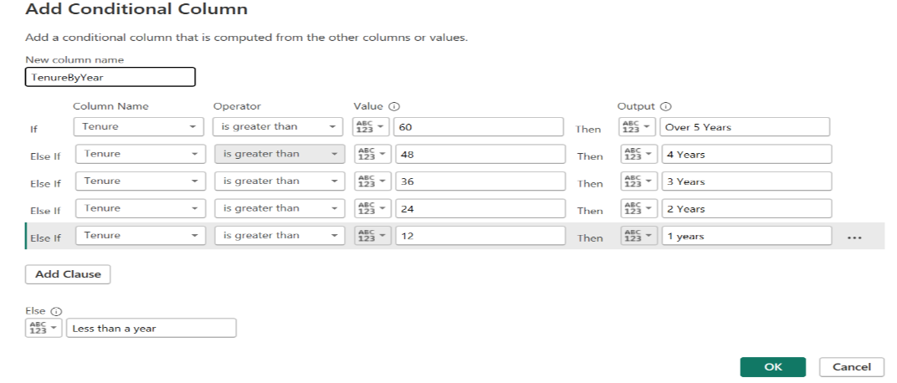

**Exploratory Data Analysis:**

Handling missing values, outliers, invalid datatypes etc. are the part of EDA process. For this dataset we do not have any of these and is clean.

Categorical analysis:

To analyze the data, need to explore it using visuals for different category(features). The feature selection process is important, because a high number of features in a dataset with a higher number of samples, leads to poor performance. which in turn leads to poor results on the validation datasets.

We can do analysis with Univariate (single category, feature or column), bivariate or multivariate. First, let me start with univariate. Let’s see how the gender is affecting the churn count.

Gender:

The total count for male is 3555 (50.48%) and female are 3488 (49.52%) are almost similar. And the churn count is also almost similar for both, male 939 (49.76%) and female 930 (50.24%). So, gender is not a vital feature for the churn decision.

Contract Type:

Now have a look at Contract type feature. We can say that contract type is an important feature from the below donut chart. From the visuals below, we can say that Month-to-Month contract type have highest churn rate with 88.55% compared to one-year or two-year fixed contract type. So, need to focus on contract type feature.

Senior citizen:

Now look at senior citizen feature. Does this affect the churn rate? From the visual, there are almost 16% of senior citizens, but the churned number is 25%. Means senior age is a one of main factor for churning out customers.

Tenure:

Now have a look at the tenure feature for total count and churned count data. Below is the bar chart for tenure as a month data. There is significant difference for the first month then rest of the months.

Let’s convert the tenure in the year instead of months for better understanding. We can see from the chart that highest churned customers have a tenure less than a year, then with 1-year and following the two-year tenure. Tenure over 3 years have less churn data. So, we can focus on to retain those customers with any loyalty program or giving some extra perks.

Customers with Multiple line:

Customer with single line and multiple line both have same churn rate percentage, almost 45% for both. But total count for single line has more counts than multiple counts. Means compared to single line, multiple line holder customers are churning more to competitors. So, we can need to give extra benefits who have multiple line as a loyal customer.

Let’s try with bivariate to fetch some more information.

If I take two variables; Gender and Contract type, I can see that there isn’t that much difference between Male and female churned count percentage. For a Female there are 2 % higher than male for a Month-to-Month contract, while other two contract types are almost same numbers.

**Conclusion**

From the Visuals, we can say that the reasons for churning customers are many for this dataset.

High Churn seen in case of Month-to-month contracts, First year of subscription, Fibre Optics Internet, No online security, and No Tech support, Customers with multiple services. Seniors (Age), Contract type (that is monthly contract type is vital for churning), Customer without partners (Single users are more churning).

Low Churn is seen in case of long-term contracts, Subscriptions without internet service and the customers engaged for 5+ years

Factors like Gender, Availability of Phone Service and number of multiple lines have almost no impact on Churn.

Customers/Subscribers churn for many reasons: Cost of Services, Competitors better pricing, Change in requirement with time, Network quality, Customer care quality etc.

**Suggestions**:

To retain the customers, we can offer loyalty program (special offers, discounts and perks to customers), Personalized plans and offers, improved customer services etc. Suppose if seniors are churning out, we can offer them tailored plan according to their need to minimize monthly bill or if multiple uses then offer them discounted plans.

**Report Pages:**

